# SENDGRID ACCOUNT CREATION:

Step1:Search for the sendgrid <https://sendgrid.com/>

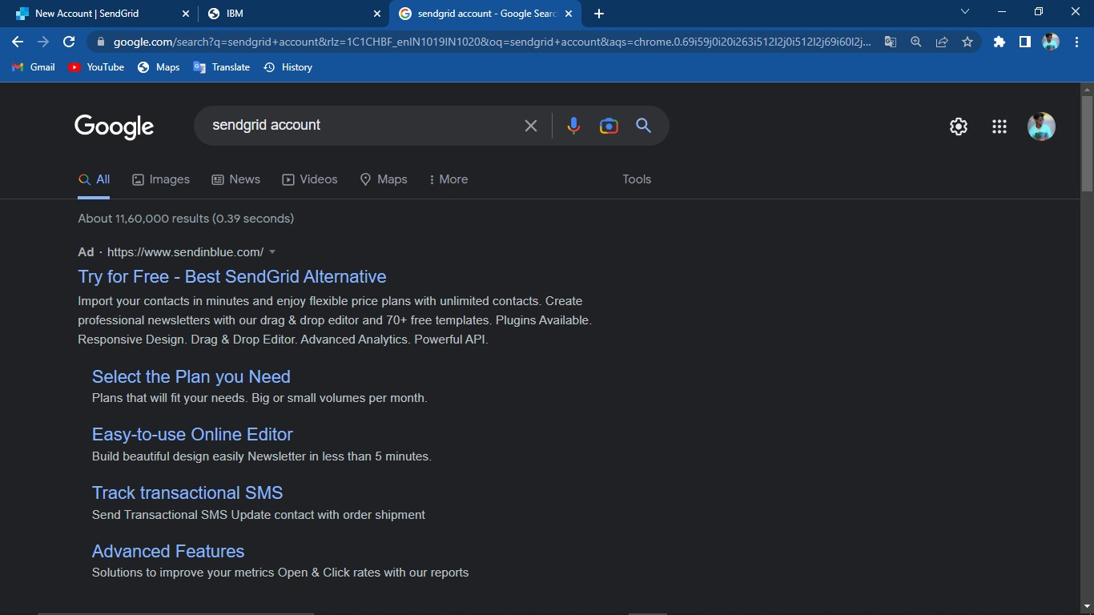

Step 2:Registering new account

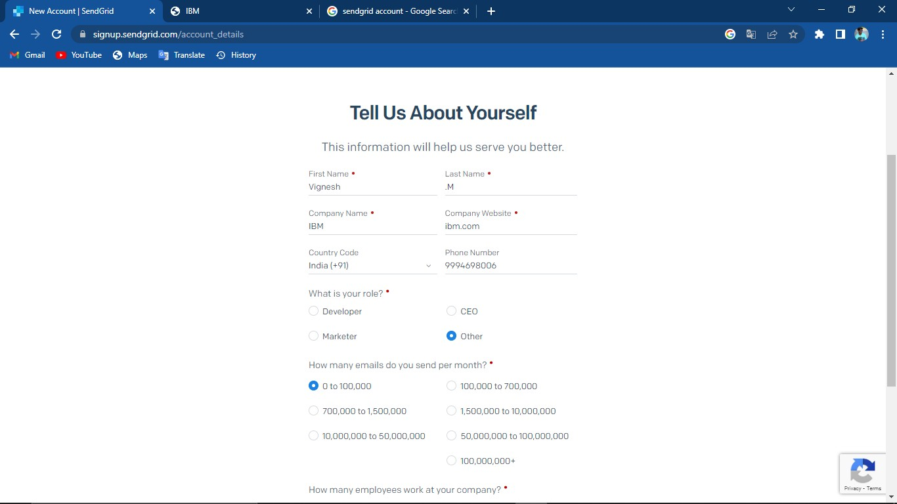

Step 3:Sendgrid account created

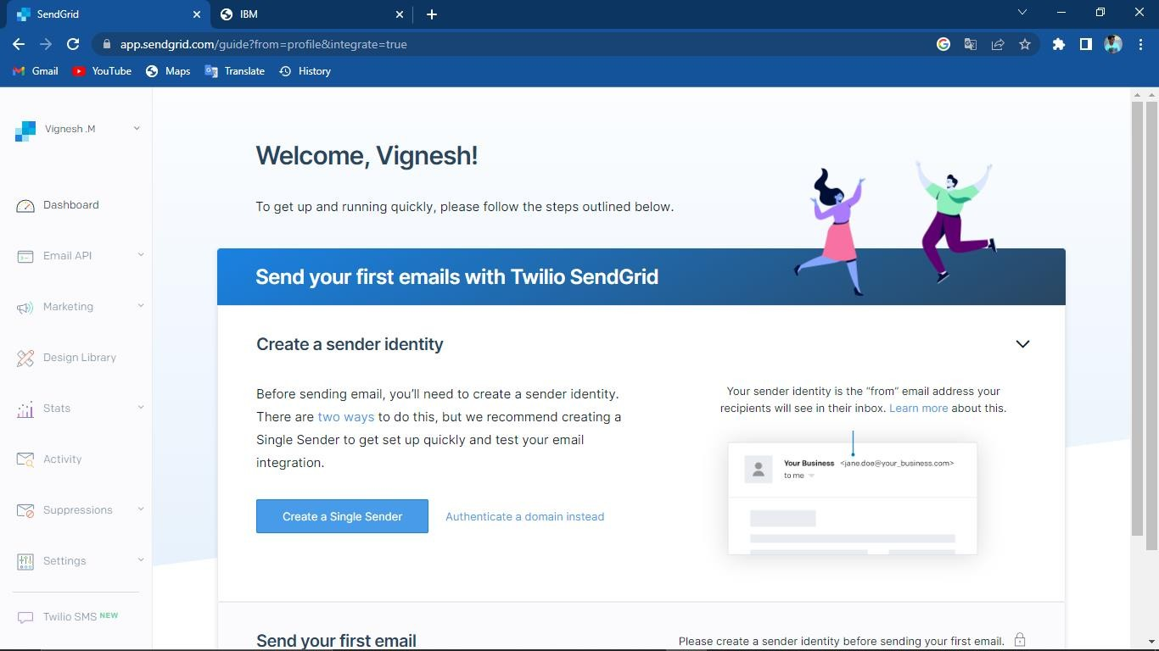

# IBM CLOUD CLI INSTALLATION: Step1:Log in to the IBM cloud

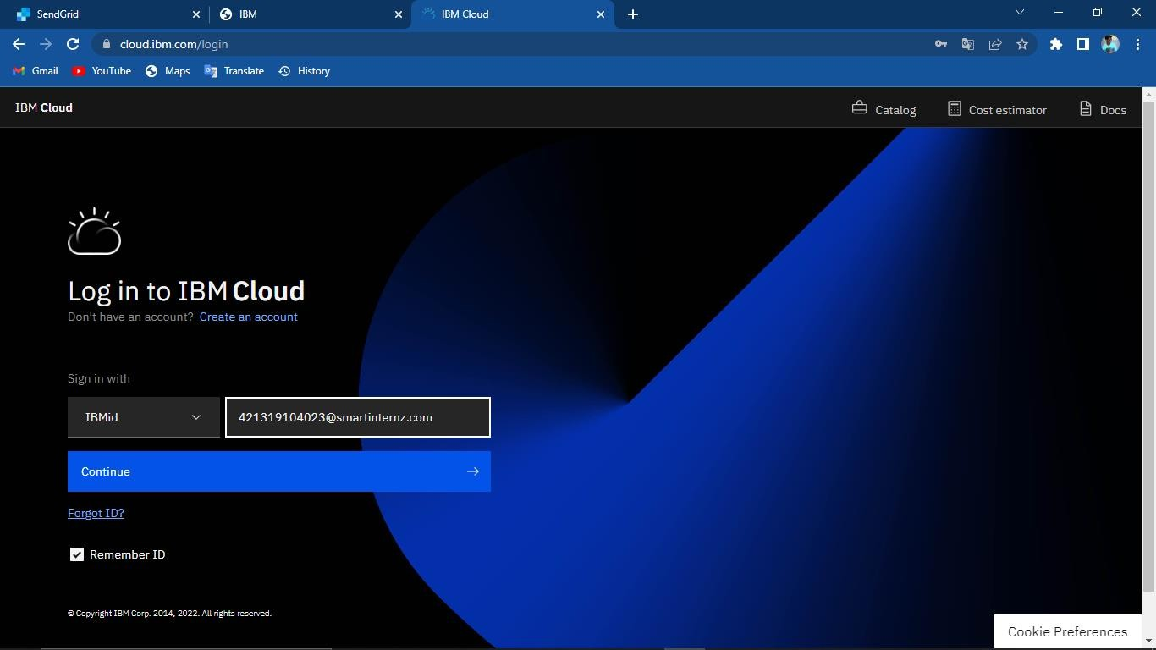

Step 2:Select container registry

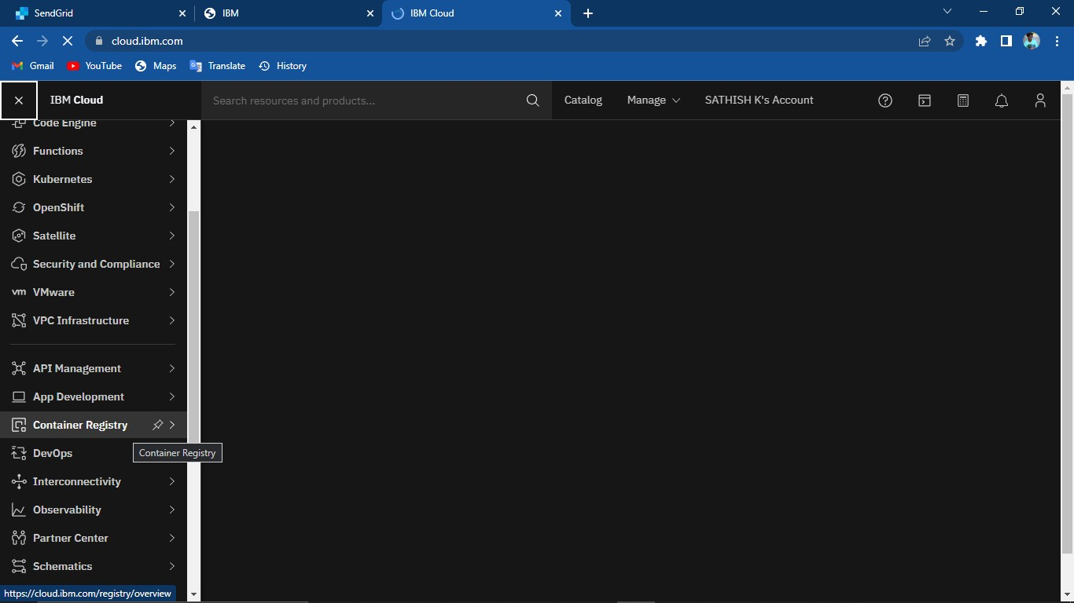

Step3: Select Quickstart to open container registry and click on install IBM Cloud CLI

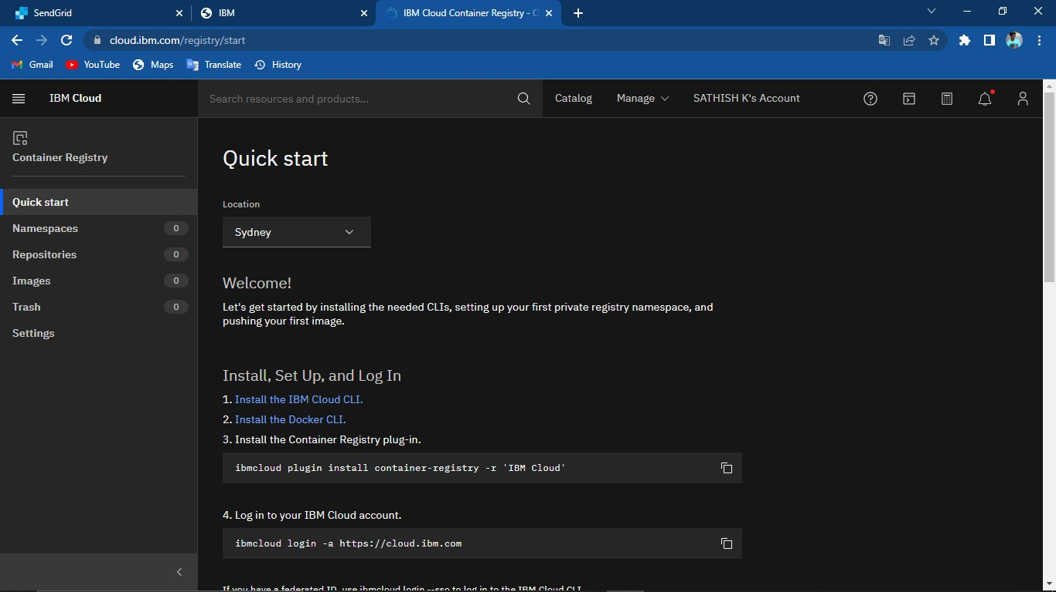

Step 4:Click on IBM Cloud CLI

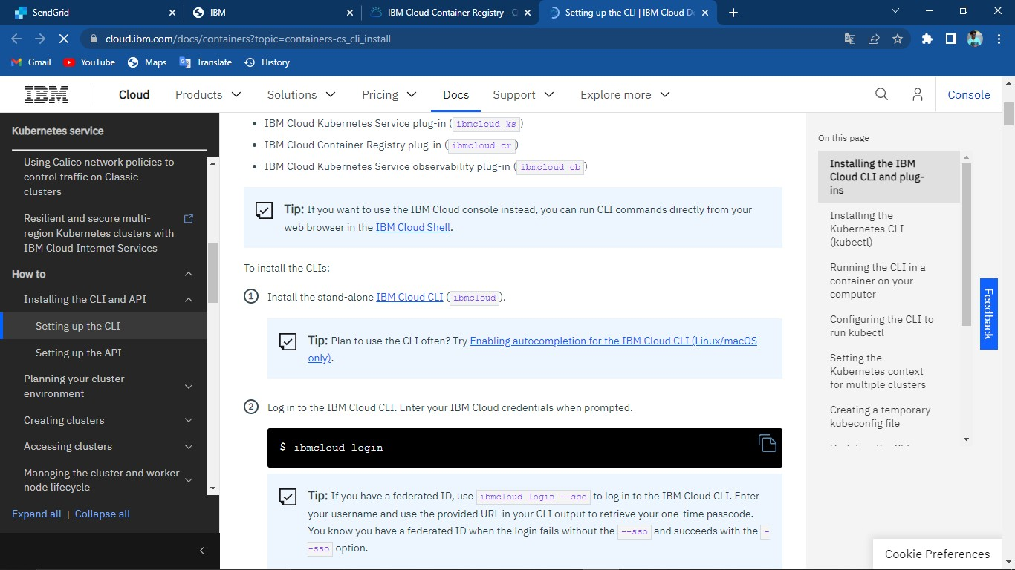

Step 5:And then,Click on IBM Cloud CLI releases

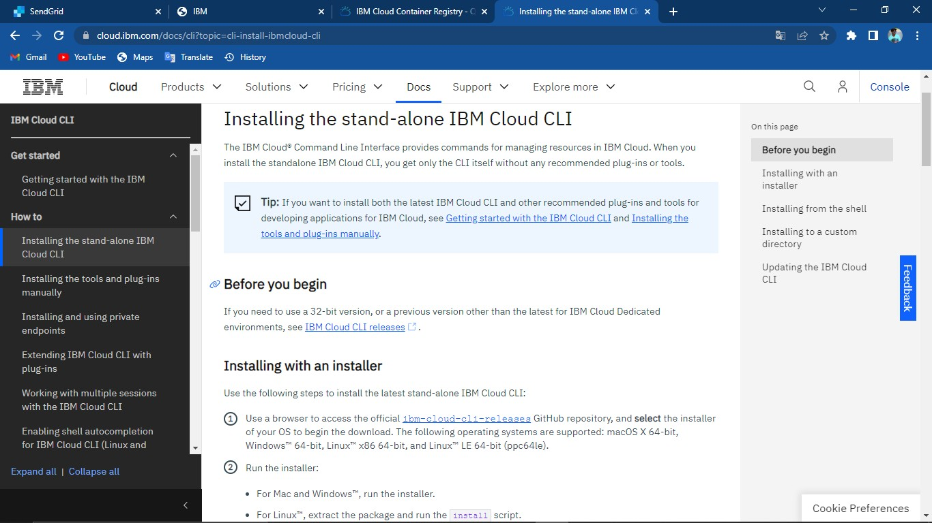

Step 6:After that,the github page will open and download the IBM CLI installer by selecting as per your system required installer.

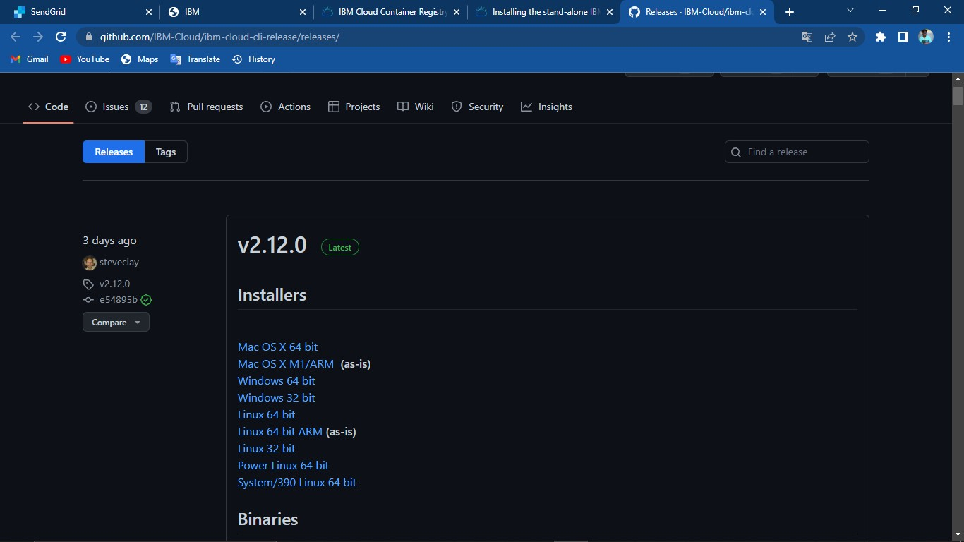

Step 7:After the download,Click the downloaded setup to run the installer

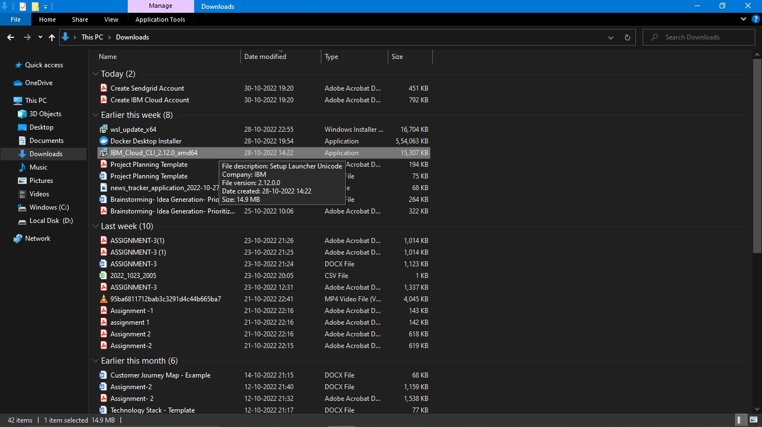

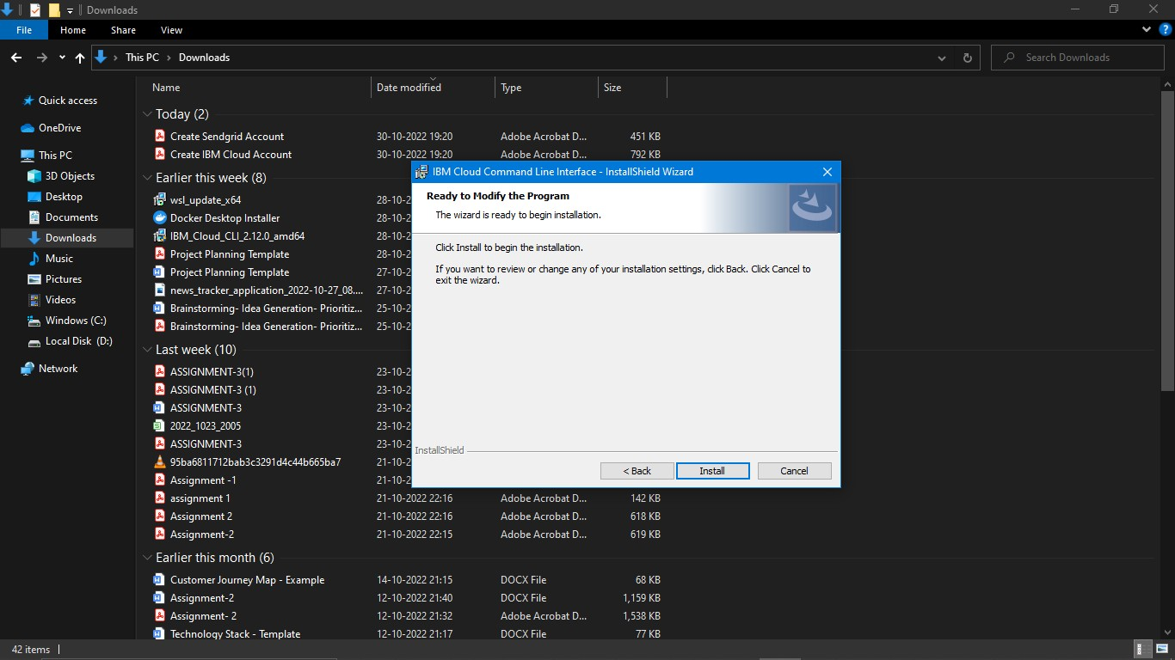

Step 8:After the installation set environment variable and then open CMD (Windows).Type this command to login in IBM cloud

“ibmcloud login”

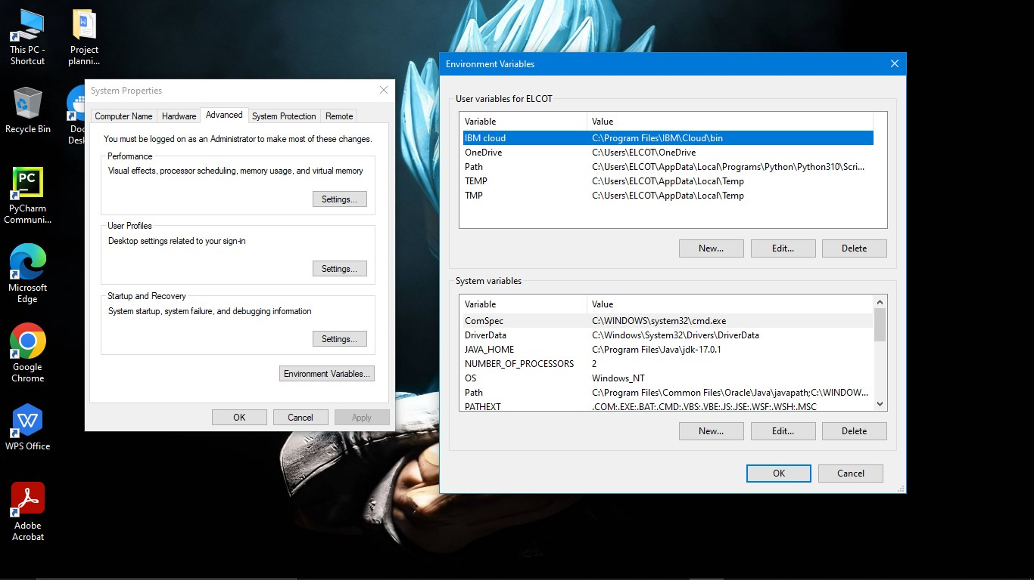

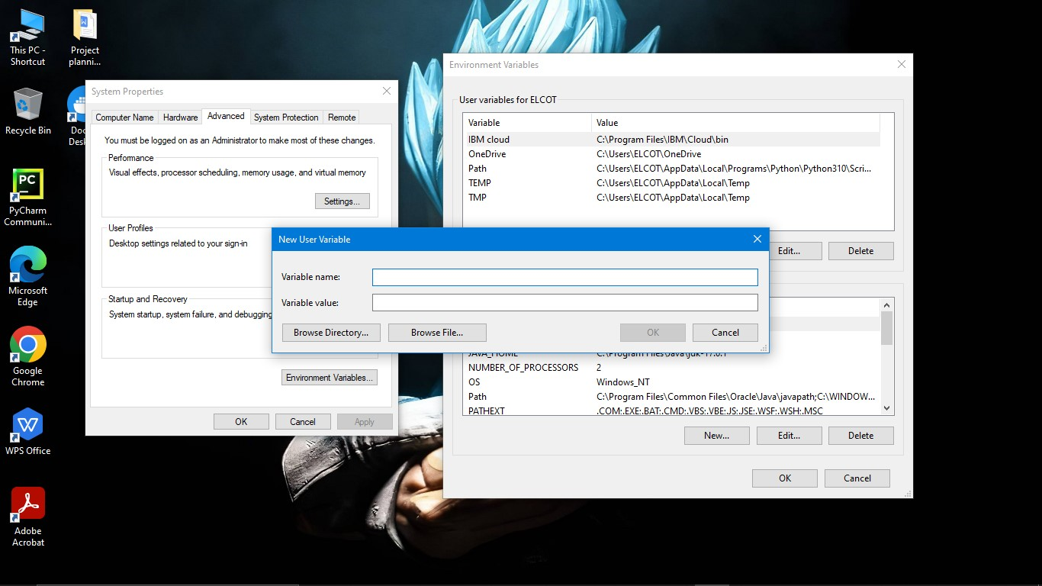

In the variable name,name it as “IBM Cloud” and in variable value the path location of the IBM.

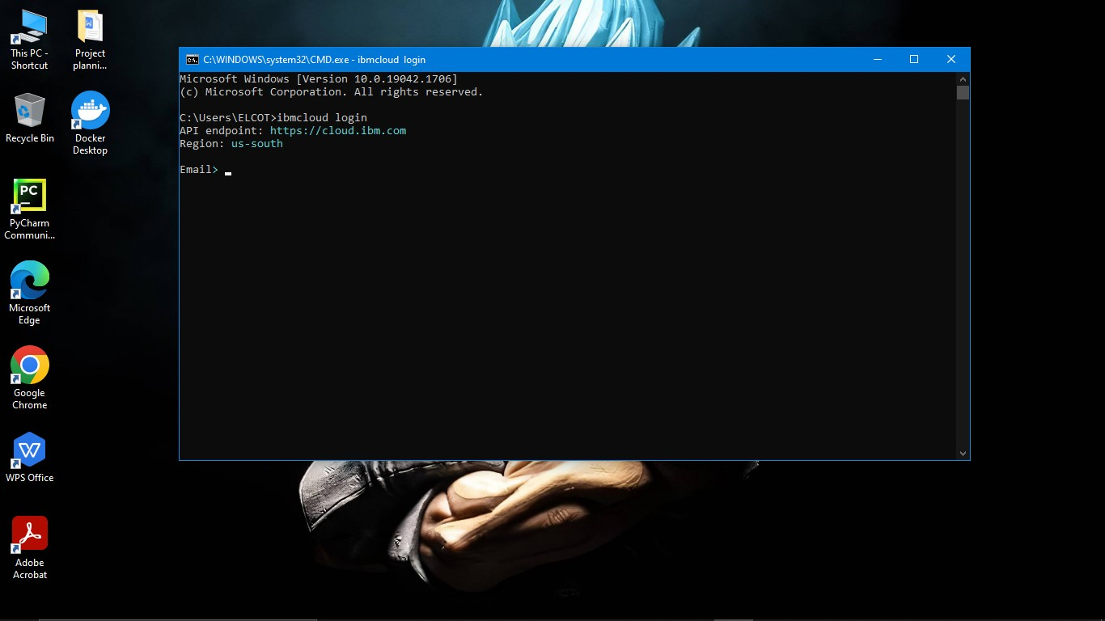

Step 9:Enter your IBM cloud email id and password ,Then it wil authenticate and signals “OK”.The number of regions will displayed, select one of them for your targeted account.

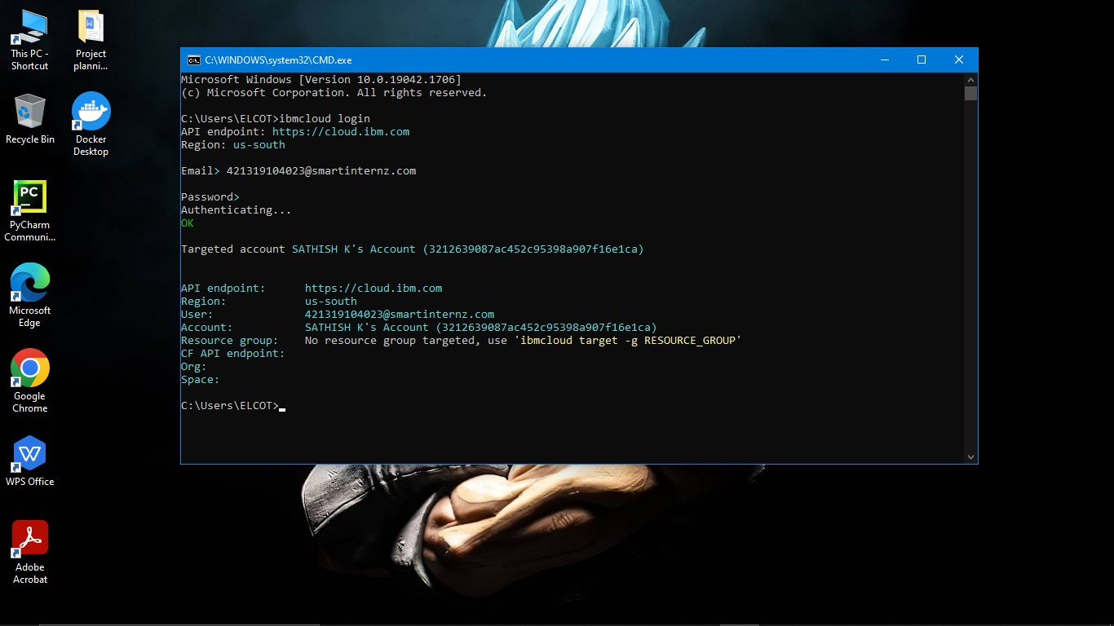

Step 10:Then copy the plugin command in your container registry (where the command displayed in your container registry which is opened on web browser) and paste and run it on cmd.

“ibmcloud plugin install container-registry -r”

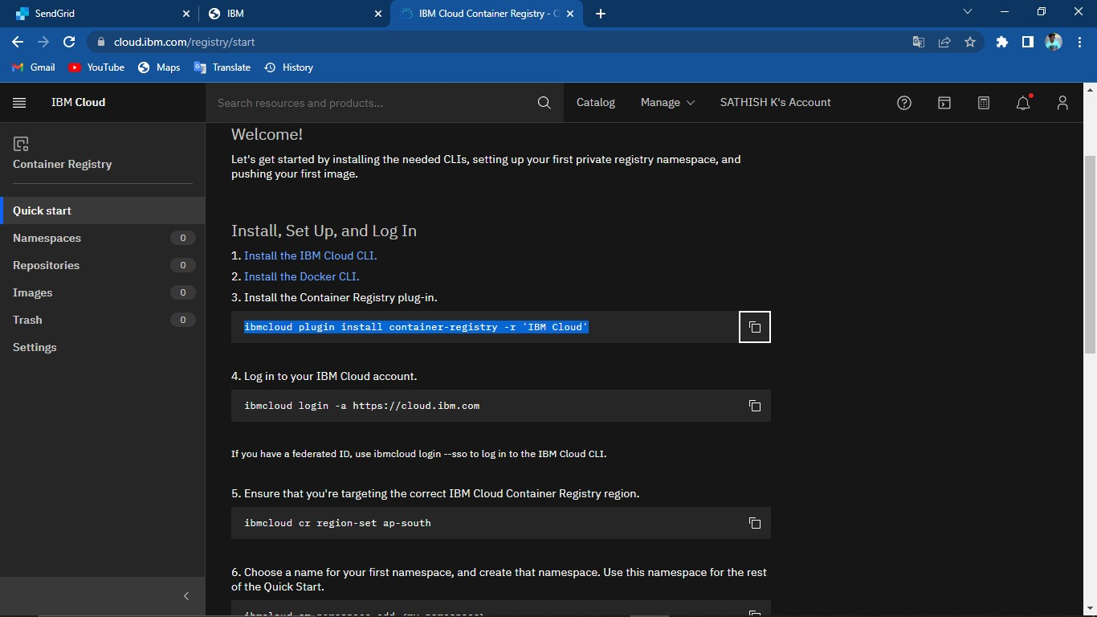

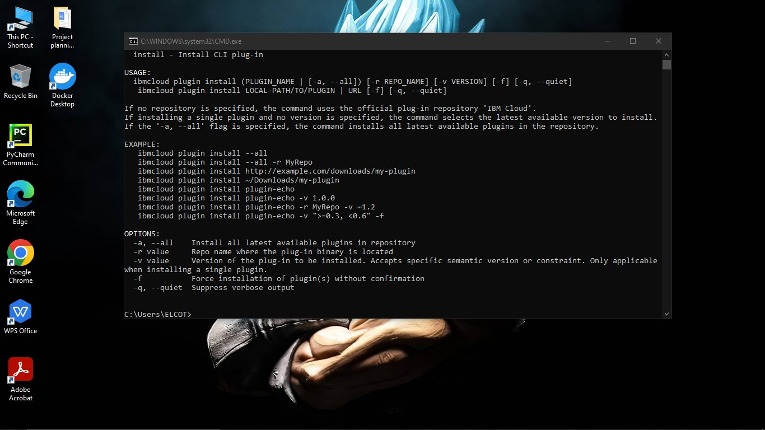

Step 11: Set your region to global . “ibmcloud cr region-set global”

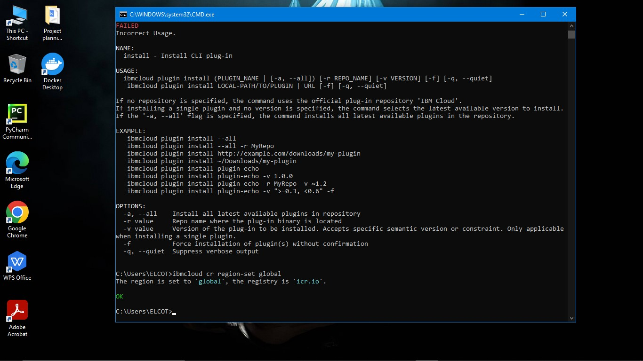

Step 12:Create namespace in your container registry

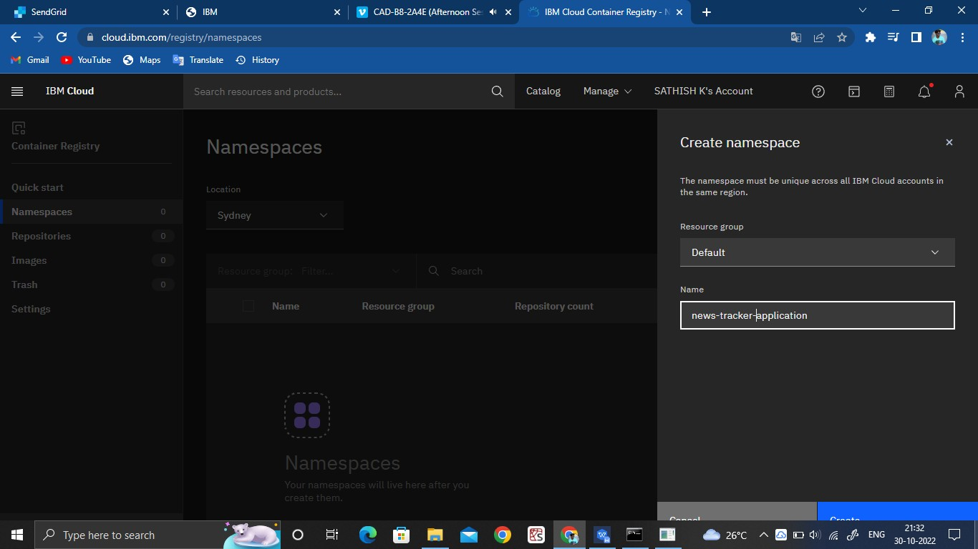

# DOCKER CLI INSTALLATION:

Step1:Open container registry in ibm cloud and click on Install Docker CLI.

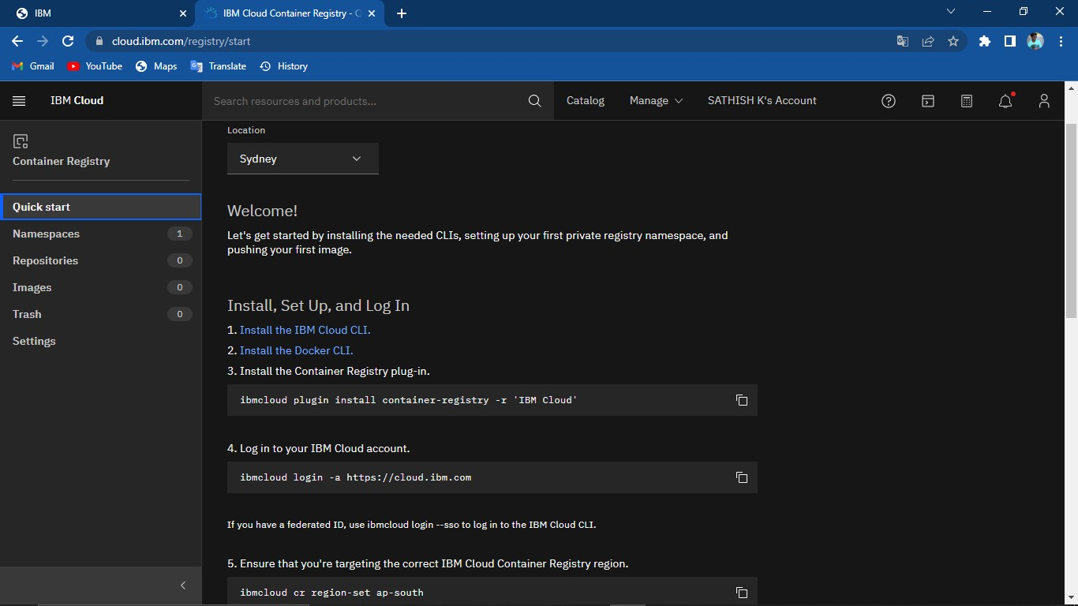

Step 2:Then,Click on required installer for your specified system and download it.

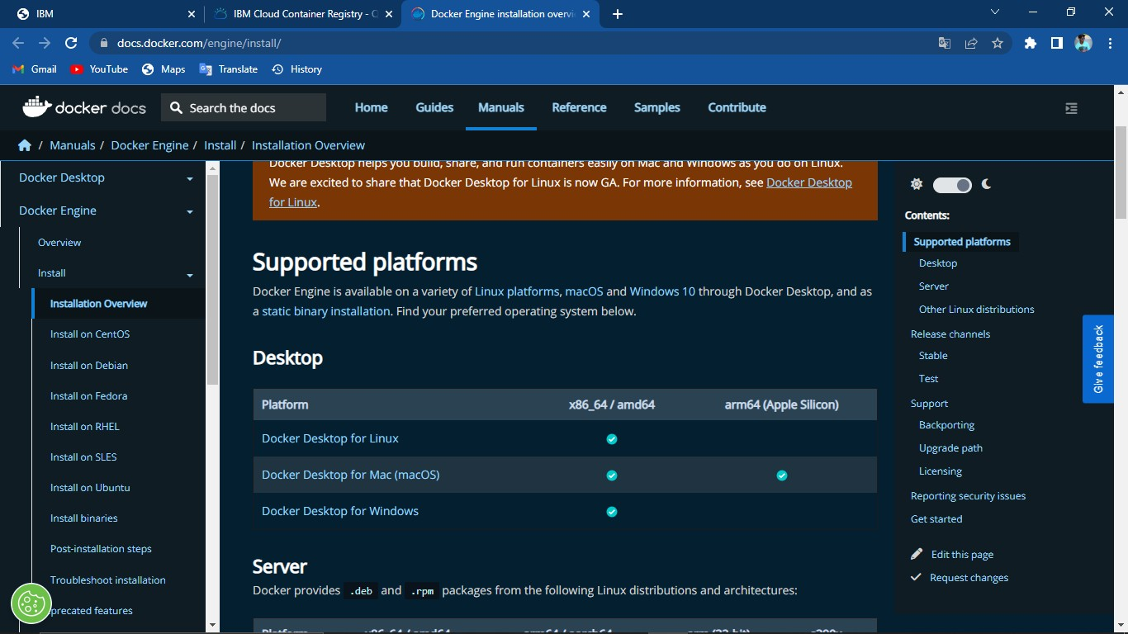

Step 3:After the setup download , run the setup and then open it and push the images, create the repository ,etc….

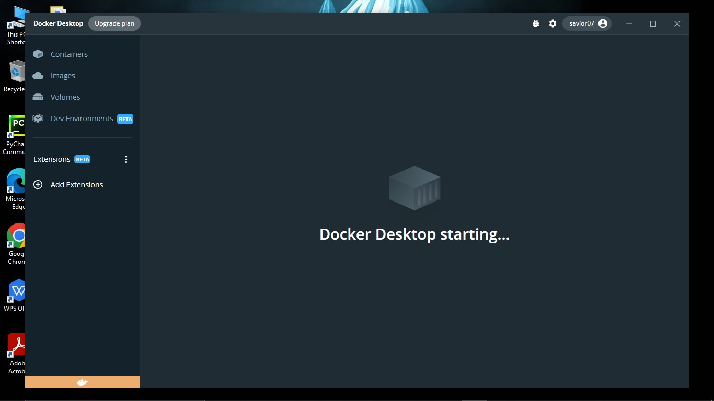

# IBM CLOUD ACCOUNT CREATION:

Step 1:Search for “ibm.com/academic” in the browser

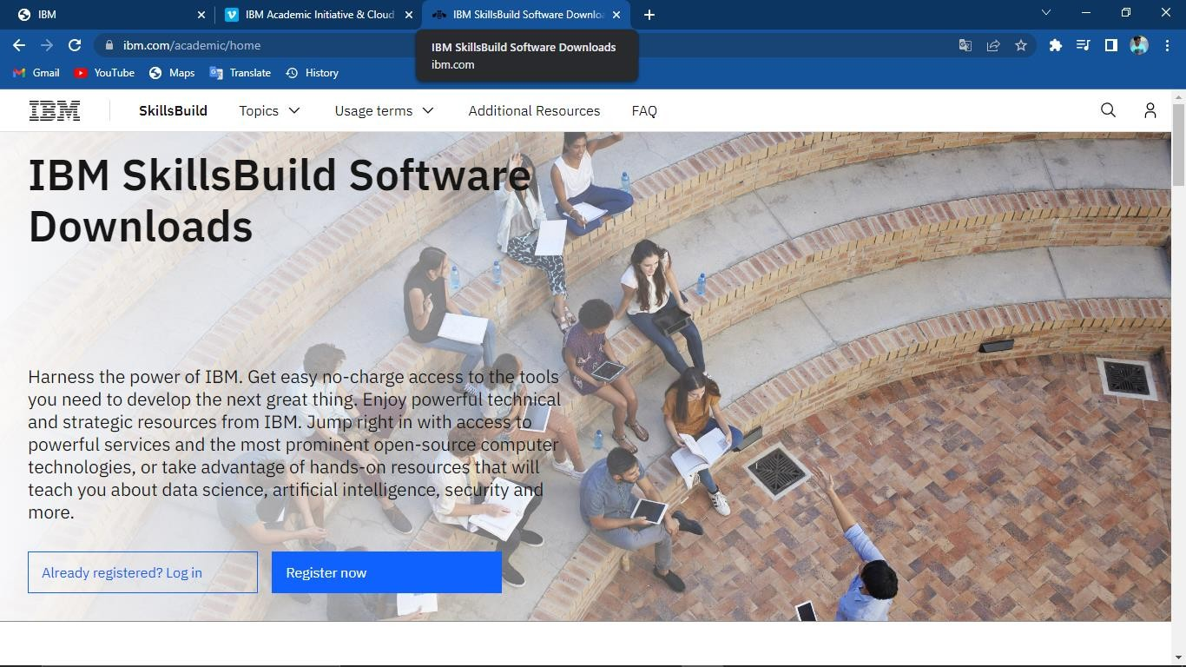

Step 2:Enter the mail issued by the academic institution and follow the procedure for entering the details which is provided as video link in your IBM profile.

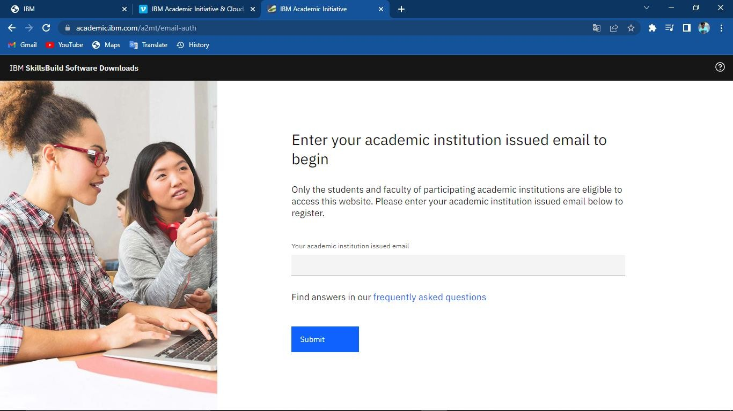

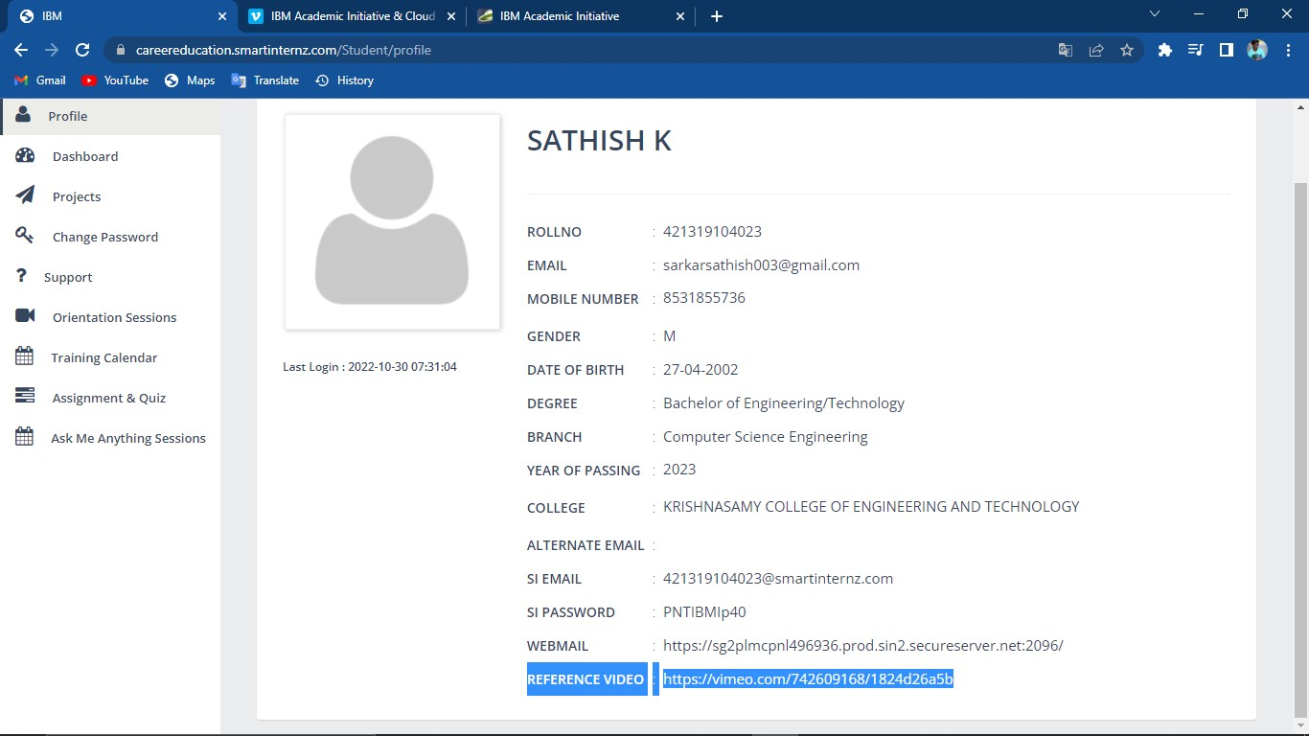

Step 3:After following the procedure that is given in reference video, your IBM cloud account wil created.

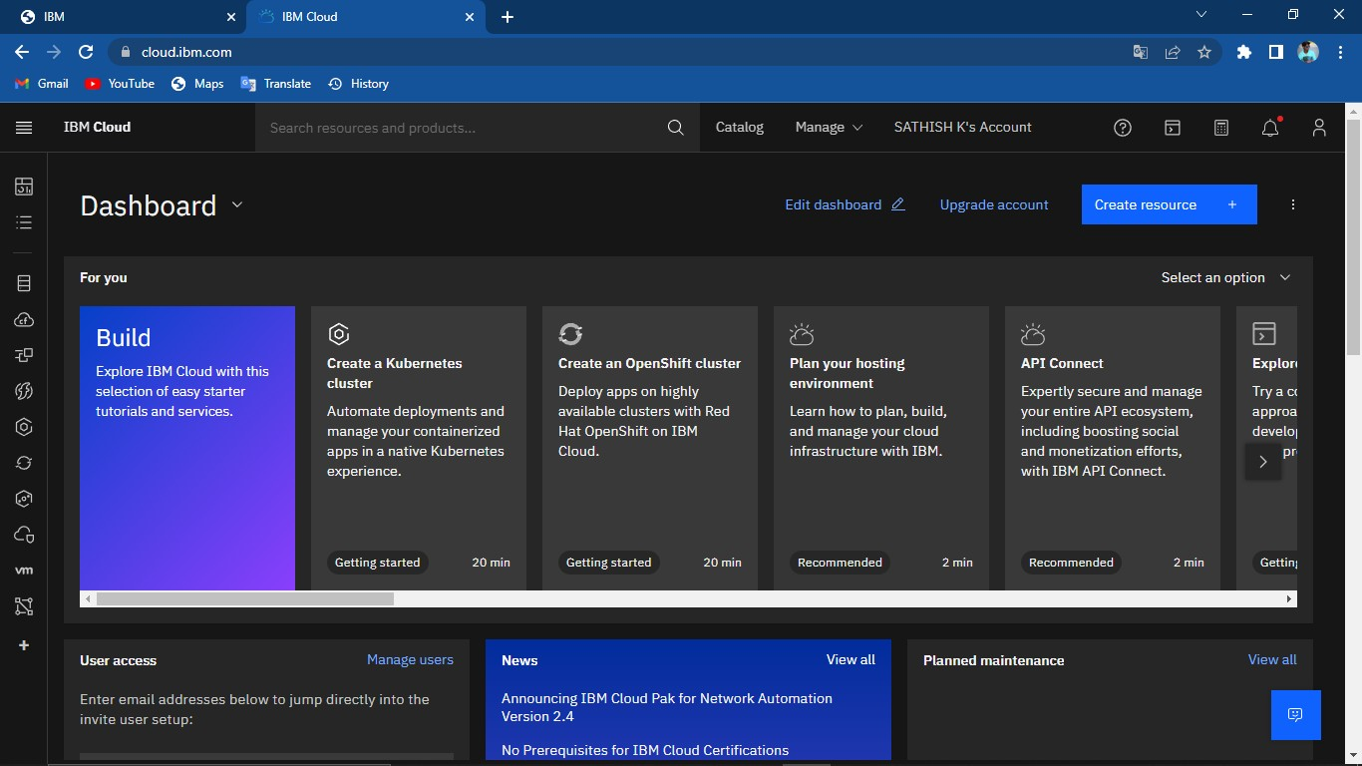

# CREATING A FLASK PROJECT:

Step1:Open pycharm in your desktop and create new project folder

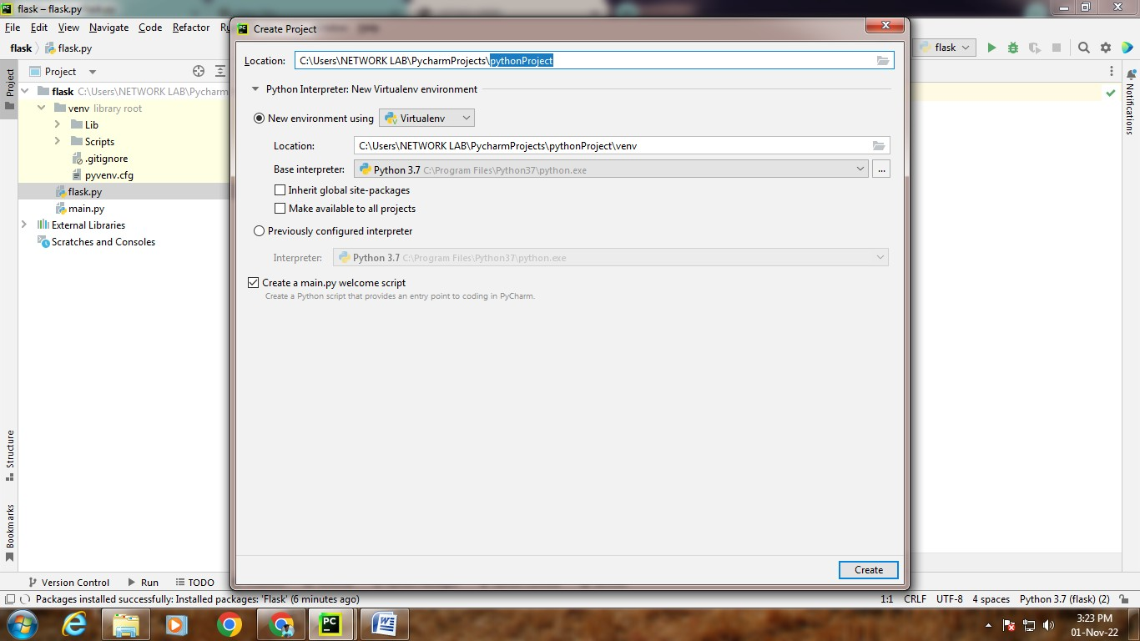

Step 2:Enter the following code to create the flask project

**from** flask **import** Flask

app = Flask( name ) @app.route(**"/"**)

**def** hello():

**return"Hello,World"**

**if** name == **' main '**: app.run()

Step 3:Then run the code, it will shows website link in terminal.

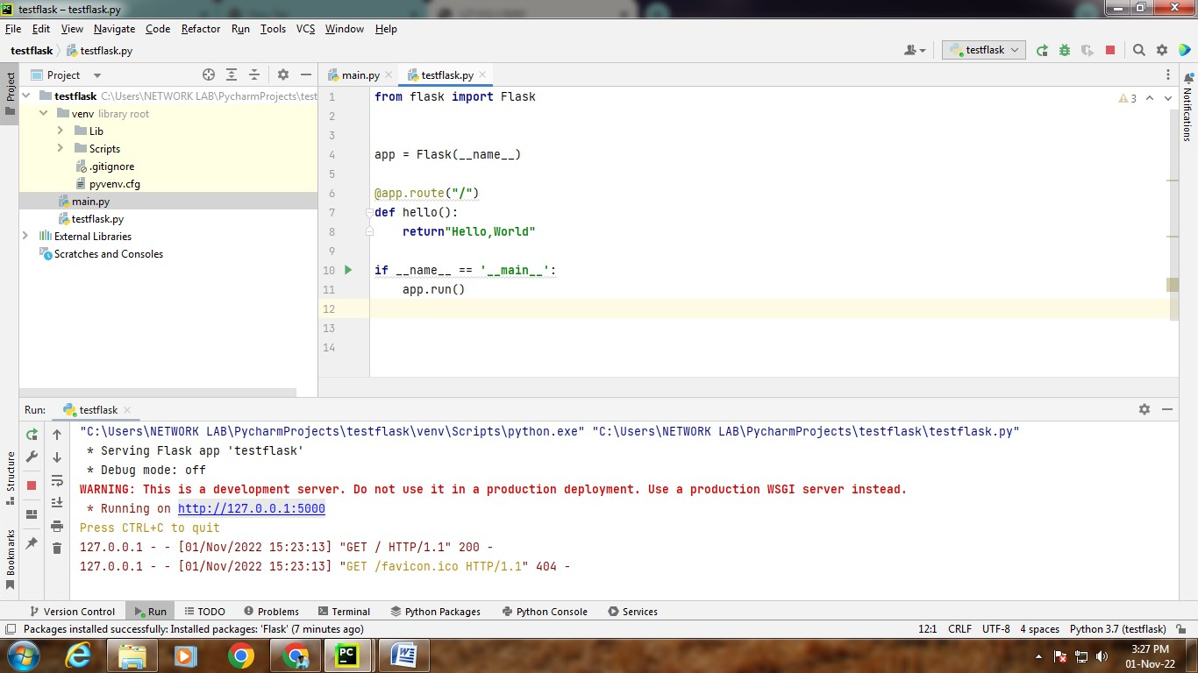

Step 4:By clicking the link in terminal, it will shows "Hello World" in the browser page.

